**Project Report**

**Stock Price Prediction using Python and Machine Learning**

This python project is created using a machine learning technique called Long Short-Term Memory (LSTM) which is using recurrent neural network (RNN) architecture.

Long Short-Term Memory (LSTM) networks are a type of recurrent neural network capable of learning order dependence in sequence prediction problems. This is a behavior required in complex problem domains like machine translation, speech recognition, and more. LSTMs are a complex area of deep learning. LSTMs are bidirectional and sequence-to-sequence related to the deep learning field. Recurrent neural networks are different from traditional feed-forward neural networks. This difference in the addition of complexity comes with the promise of new behaviors that the traditional methods cannot achieve.

I want my program to predict the stock prices of Starbucks coffee shops based on the previous year’s closing stock prices.

First, I import the required libraries and then get the live stock prices from yahoo finance for Starbucks coffee shops from January 1st, 2012 to June 10th, 2020.

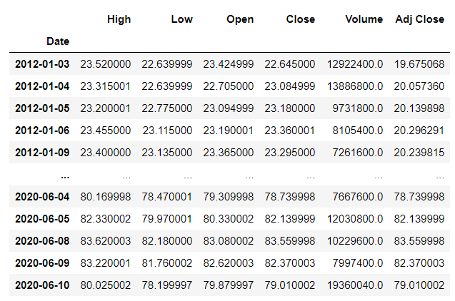

Next, I use the df.shape command to find the number of rows and columns in the dataset. Now we will visualize the close price history of the stock.

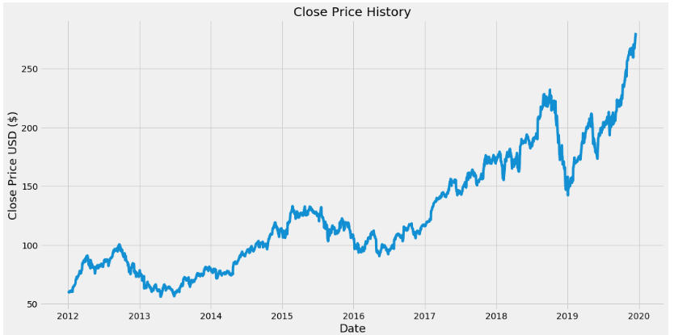

Now we will create a new data frame with only the closing price and convert it to an array. Then we will create a variable to store the length of the training data set. We want the training data set to contain about 80% of the data.

Then we will scale the data set to be values between 0 and 1 and we need to reshape the data into 3-dimensional form because LSTM model requires a 3-dimensional data set.

Now we need to build the LSTM model to have two LSTM layers with 50 neurons and two Dense layers, one with 25 neurons and the other with 1 neuron.

Then we compile the model using the mean squared error loss function and then we train the model using training data set.

Now we will create a test data set and then convert the independent test data set to a numpy array so it can be used for testing the LSTM model.

Then we should get the predicted values from the model using the test data and now we will calculate the value of root mean squared error (RMSE) which a good measure of how accurate the model is so the lower the RMSE value is the better the model will perform. A value of 0 RMSE indicate that the model is perfect.

Now we will plot a graph to show the predicted and actual closing stock prices of the stock.

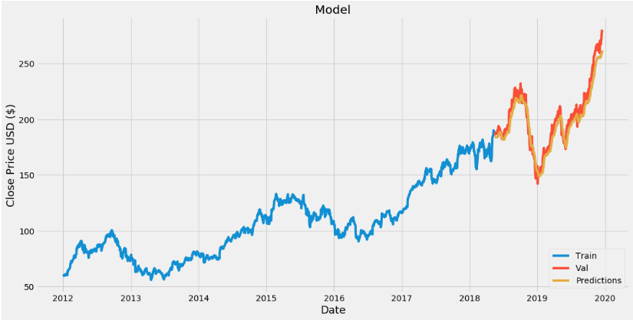

Now I will show the predicted and actual stock prices of the stock in a table form to get a more accurate look of the stock prices.

